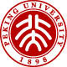
SEMINAR
SERIES
力学与工程科学学院
航空航天工程系
湍流与复杂系统国家重点实验室
题目：Combustion of Zero- and Low-Carbon Fuels: From Droplet-Scale Phenomena to Low-Emission Technologies
报告人: Pedro Magalhães
Escola Politécnica, University of São Paulo (USP)
报告内容摘要 Abstract：
Decarbonising transport, power, and industry relies on the clean, stable, and safe combustion of zero- and low-carbon fuels. In this talk, I will give an overview of my contributions to combustion research, focusing on multiscale problems in combustion transients, stability and emissions. Attention will be given to ignition and the droplet-scale flame phenomena in sustainable aviation fuel (SAF) sprays, and the development of low-emissions combustion technologies for SAFs and hydrogen. I will close with an outlook on new research directions and opportunities for PKU–USP collaborations.
报告人简介 Speaker：
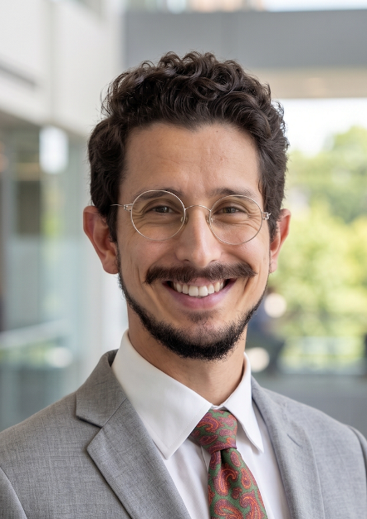Pedro Magalhães works in engineering and thermal sciences, focusing on multiphysics and multiscale problems in fluid flows. He completed his PhD at Cambridge (2019) and worked as a Research Associate in projects ranging from gas turbine combustion to aerosol formation. In 2024, he joined the University of São Paulo in Brazil, where he is now establishing his research group on energy conversion and process safety technologies for the energy transition. He has received distinctions such as the Da Vinci Medal (2021, ERCOFTAC) and the Clean Sky Best PhD Award (2020, European Commission). In 2022, he was named an emerging leader by Measurement Science and Technology and received the Combustion Institute’s Bernard Lewis Fellowship. He has contributed to the US National Jet Fuels Combustion Program and the UK Royal Society’s Rapid Assistance in Modelling the Pandemic, and is currently an ABCM delegate to ERCOFTAC and a member of the Combustion Institute’s EC Advisory Committee. His research interests include fundamental experiments, modelling and development of advanced diagnostics for low/zero-carbon energy-conversion technologies and process safety applications in the energy, transport, and O&G sectors.

时间：2026年7月24日（周五）中午15:00 – 16:30
地点：北京大学 新奥工学大楼 3048会议室
欢迎校内外师生参加！
联系人：陈帜 chenzhi@pku.edu.cn

